August 3, 2025

Initial Table Set Up

-- drops tables for testing, i had to reconnect to db to test

-- Unsure if we need this

drop table reservation_room cascade constraints;

drop table service cascade constraints;

drop table reservation cascade constraints;

drop table guest cascade constraints;

drop table room cascade constraints;

drop table hotel cascade constraints;

-- hotel table (hid is pk)

create table hotel (

hid number primary key,

hname varchar2(50),

haddress varchar2(50),

hcity varchar2(50),

hstate varchar2(50),

hphone number

);

-- rid is pk, hid fk

create table room (

rid number primary key,

hid number,

rnumber number,

rtype varchar2(50),

r_ratePerNight number,

r_rateType number,

foreign key (hid) references hotel(hid)

);

-- gid is pk

create table guest (

gid number primary key,

gname varchar2(50),

gaddress varchar2(50),

gphone number,

g_creditCard varchar2(50)

);

-- resid is pk

-- gid & hid are fk

create table reservation (

resid number primary key,

gid number,

hid number,

resdate varchar2(50),

res_startDateg varchar2(50),

res_endDate varchar2(50),

res_discount number,

foreign key (gid) references guest(gid),

foreign key (hid) references hotel(hid)

);

-- res_roomid is pk

-- resid & rid are fk

create table reservation_room (

res_roomid number primary key,

resid number,

rid number,

foreign key (resid) references reservation(resid),

foreign key (rid) references room(rid)

);

-- sid pk

-- resid fk

create table service (

sid number primary key,

resid number,

stype varchar2(50),

squantity number,

sdate varchar2(50),

sprice number,

foreign key (resid) references reservation(resid)

);

-- insert sample data

insert into hotel values (1, 'Carls Hilton', '1234 Main Street', 'Baltimore', 'MD', '4444444444');

insert into hotel values (2, 'Alexs Hilton', '0000 Nope Lane', 'Bel Air', 'MD', '5555555555');

insert into hotel values (3, 'Erzas Hilton', '63362 Creativity Drive', 'Laurel', 'MD', '666666666');

-- room

insert into room values (1, 1, 101, 'Single', 100, 1);

insert into room values (2, 1, 102, 'Double', 150, 2);

insert into room values (3, 2, 201, 'Conference', 300, 3);

-- guest

insert into guest values (1, 'Barack Obama', '1234 Example Street', '1111111111', '0000000000');

insert into guest values (2, 'Pikachu', '5678 Hillstop Circle', '2222222222', '1111111111');

insert into guest values (3, 'Michael Jordan', '90123 Catnip Lane', '3333333333', '222222222');

-- reservation

insert into reservation values (1, 1, 1, '2025-01-01', '2025-04-04', '2025-05-05', 5);

insert into reservation values (2, 2, 2, '2025-02-02', '2025-05-04', '2025-06-05', 10);

insert into reservation values (3, 3, 3, '2025-03-03', '2025-06-04', '2025-07-05', 15);

-- reservation room

insert into reservation_room values (1, 1, 1);

insert into reservation_room values (2, 2, 2);

insert into reservation_room values (3, 3, 3);

-- service

insert into service values (1, 1, 'Restaurant', 1, '2025-04-06', 10);

insert into service values (2, 2, 'Laundry', 2, '2025-05-06', 20);

insert into service values (3, 3, 'Movie', 3, '2025-06-06', 30);

1. Add a new hotel: Create a new hotel with appropriate information about the hotel as input parameter

-- add a hotel entities (see d1)

create or replace procedure add_new_hotel(

hid in number,

hname in varchar2,

haddress in varchar2,

hcity in varchar2,

hstate in varchar2,

hphone in number

) as

-- starts

Begin

insert into hotel (hid, hname, haddress, hcity, hstate, hphone)

-- inserts values

values (hid, hname, haddress, hcity, hstate, hphone);

-- print if successful

dbms_output.put_line('Hotel added!');

exception

when others then

-- print a generic error on exception

dbms_output.put_line('Error adding hotel! Please check your values');

end;

/

**Screenshot**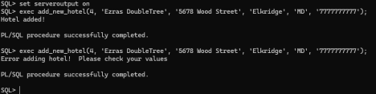

2. Find a hotel: Provide as input the address of the hotel and return its hotel ID

-- Find address and return values to use

create or replace function find_hotel_by_address(

addr in varchar2) return number as

hid number;

hname varchar2(50);

begin

select hid,

hname into hid,

hname from hotel

where haddress = addr;

-- print hotel name when found

dbms_output.put_line(hname);

-- return hid for usage later

return hid;

exception

when others then

dbms_output.put_line('Error finding hotel!');

-- return nothing when failed

return null;

end;

/

**Screenshot**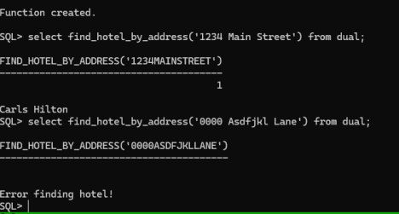

3. Sell existing hotel: Sell a hotel by providing its hotel ID. Mark it as sold, do not delete the record.

-- This adds a table which wasn't in D1

alter table hotel add (is_sold number default 0);

-- Get hid for usage

create or replace procedure sell_hotel(

hid in number

) as

begin

-- update is_sold for hotel & print message

update hotel set is_sold = 1 where hid = hid;

dbms_output.put_line('Hotel marked as sold!');

exception

when others then

dbms_output.put_line('Error marking hotel as sold!'); end;

/

**Screenshot**

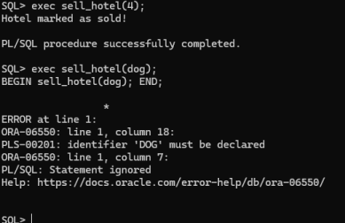

**3. Testing**

-- THIS IS NEEDED TO PRINT EXCEPTIONS

set serveroutput on

-- Add hotel, this is just a random example

exec add_new_hotel(4, 'Ezras DoubleTree', '5678 Wood Street',

'Elkridge', 'MD', '7777777777');

-- run again to get an exception (duplicate)

exec add_new_hotel(4, 'Ezras DoubleTree', '5678 Wood Street',

'Elkridge', 'MD', '7777777777');

-- Find hotel by address

select find_hotel_by_address('1234 Main Street') from dual;

-- Run with something that doesnt exist to get an exception

select find_hotel_by_address('0000 Asdfjkl Lane') from dual;

-- Mark hotel as sold

exec sell_hotel(4);

-- Not the exception exactly, but it'll fail on bad inputs

exec sell_hotel(dog);

4. Make a reservation: Input parameters: Hotel, guest’s name, start date, end dates, room type, date of reservation, etc. Output: reservation ID (this is called confirmation code in real-life ). NOTE: Only one guest per reservation. However, the same guest can make multiple reservations

create or replace procedure make_reservation (

p_hotel_name in varchar2,

p_guest_name in varchar2,

p_res_date in date,

p_start_date in date,

p_end_date in date,

p_room_type in varchar2,

p_discount in number,

p_confirmation out number

)

as

v_hid hotel.hid%type;

v_gid guest.gid%type;

v_rid room.rid%type;

v_resid reservation.resid%type;

v_res_roomid reservation_room.res_roomid%type;

begin

-- find the hotel ID

select hid into v_hid

from hotel

where hname = p_hotel_name;

-- find the guest ID

select gid into v_gid

from guest

where gname = p_guest_name;

-- find an available room of the right type in that hotel

select rid into v_rid

from room

where hid = v_hid

and rtype = p_room_type

and rownum = 1; -- just grab one available room

-- get new reservation ID

select reservation_seq.nextval into v_resid from dual;

-- insert into reservation

insert into reservation (resid, gid, hid, resdate, res_startDateg, res_endDate, res_discount)

values (v_resid, v_gid, v_hid, p_res_date, p_start_date, p_end_date, p_discount);

-- get new reservation_room ID

select reservation_room_seq.nextval into v_res_roomid from dual;

-- link room to reservation

insert into reservation_room (res_roomid, resid, rid)

values (v_res_roomid, v_resid, v_rid);

-- return reservation ID as confirmation code

p_confirmation := v_resid;

exception

when no_data_found then

raise_application_error(-20001, 'Hotel, guest, or room type not found.');

when others then

raise_application_error(-20002, 'Something went wrong: ' || sqlerrm);

end;

/

**Output:**

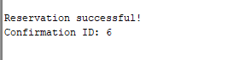

5. Find a reservation: Input is guest’s name and date, hotel ID. Output is reservation ID

set serveroutput on;

-- manually adding a new reservation to test the find_reservation function

-- I'm using ID 4 since IDs 1-3 are already taken

insert into reservation values (4, 2, 2, '2025-07-01', '2025-07-10', '2025-07-15', 0);

insert into reservation_room values (4, 4, 2);

-- turn on output so I can see the DBMS_OUTPUT messages

set serveroutput on;

-- creating the function find_reservation

-- this function checks if a guest has a reservation at a hotel on a specific date

-- input: guest name (p_gname), date to check (p_date), hotel id (p_hid)

-- output: reservation id if found, otherwise null

create or replace function find_reservation (

p_gname in varchar2,

p_date in varchar2,

p_hid in number

) return number

as

v_resid number; -- this will store the reservation id if we find one

begin

-- trying to find a reservation that matches the guest, hotel, and date

select r.resid into v_resid

from reservation r

join guest g on r.gid = g.gid

where g.gname = p_gname

and r.hid = p_hid

and p_date between r.res_startDateg and r.res_endDate;

return v_resid; -- if we get here, the reservation was found

exception

when no_data_found then

-- if no reservation is found, this message shows up

dbms_output.put_line('no reservation found for guest ');

return null;

when others then

-- if there's some other error (like typo or table issue), this will catch it

dbms_output.put_line('error finding reservation: ');

return null;

end;

/

**Output:**

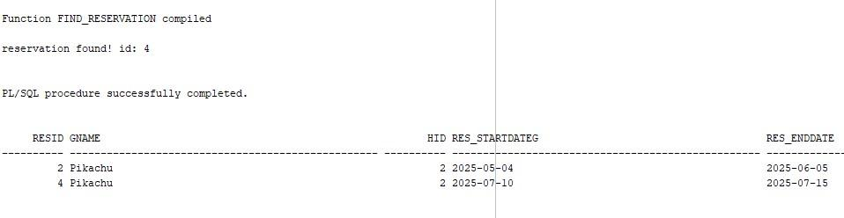

**Calling Function:**

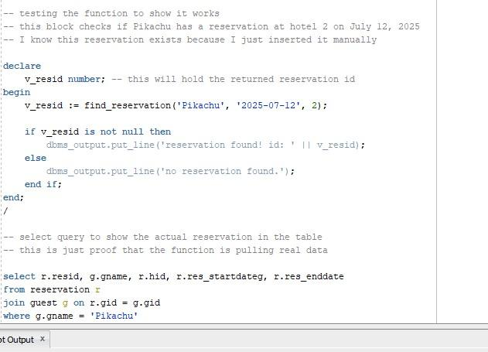

6. Add a service to a reservation: Input: ReservationID, specific service. Add it to the reservation for a particular date. Multiple services are allowed on a reservation for the same date.

CREATE OR REPLACE PROCEDURE AddServiceToReservation(

p_reservation_id IN NUMBER,

p_service_name IN VARCHAR2,

p_service_date IN VARCHAR2, -- stored as string in your table

p_quantity IN NUMBER,

p_price IN NUMBER

)

IS

v_sid NUMBER;

BEGIN

-- Get next available sid

SELECT NVL(MAX(sid), 0) + 1 INTO v_sid FROM service;

-- Insert into service table

INSERT INTO service (sid, resid, stype, squantity, sdate, sprice)

VALUES (v_sid, p_reservation_id, p_service_name, p_quantity, p_service_date, p_price);

-- Confirm success

DBMS_OUTPUT.PUT_LINE('Service "' || p_service_name || '" added to reservation ID ' || p_reservation_id || ' on ' || p_service_date);

EXCEPTION

WHEN OTHERS THEN

DBMS_OUTPUT.PUT_LINE('Error adding service: ' || SQLERRM);

END;

/

--Callprocedure

BEGIN

AddServiceToReservation(1, 'Spa', '2025-08-04', 2, 60);

END;

/

--Query service table

SELECT * FROM service WHERE resid = 1;

**Output:**

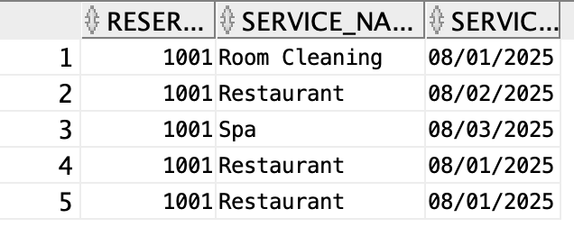

7. Show reservation details: Input the reservation ID and print all information about this Reservation

-- Create reservations table

CREATE TABLE reservations (

reservation_id NUMBER PRIMARY KEY,

guest_name VARCHAR2(100),

hotel_id NUMBER,

room_type VARCHAR2(50),

start_date DATE,

end_date DATE,

status VARCHAR2(20)

);

-- Create reservation_services table

CREATE TABLE reservation_services (

reservation_id NUMBER,

service_name VARCHAR2(100),

service_date DATE

);

-- Insert sample reservation

INSERT INTO reservations (

reservation_id, guest_name, hotel_id, room_type, start_date, end_date, status

) VALUES (

1001, 'John Smith', 2, 'Suite',

TO_DATE('2025-08-01', 'YYYY-MM-DD'),

TO_DATE('2025-08-10', 'YYYY-MM-DD'),

'Active'

);

-- Insert related services

INSERT INTO reservation_services (reservation_id, service_name, service_date)

VALUES (1001, 'Restaurant', TO_DATE('2025-08-01', 'YYYY-MM-DD'));

INSERT INTO reservation_services (reservation_id, service_name, service_date)

VALUES (1001, 'Spa', TO_DATE('2025-08-03', 'YYYY-MM-DD'));

-- Commit changes

COMMIT;

-- Drop and recreate the procedure

BEGIN

EXECUTE IMMEDIATE 'DROP PROCEDURE ShowReservationDetails';

EXCEPTION

WHEN OTHERS THEN NULL;

END;

/

CREATE OR REPLACE PROCEDURE ShowReservationDetails(

p_reservation_id IN NUMBER

)

IS

v_guest_name VARCHAR2(100);

v_hotel_id NUMBER;

v_room_type VARCHAR2(50);

v_start_date DATE;

v_end_date DATE;

v_status VARCHAR2(20);

BEGIN

SELECT guest_name, hotel_id, room_type, start_date, end_date, status

INTO v_guest_name, v_hotel_id, v_room_type, v_start_date, v_end_date, v_status

FROM reservations

WHERE reservation_id = p_reservation_id;

DBMS_OUTPUT.PUT_LINE('--- Reservation Details ---');

DBMS_OUTPUT.PUT_LINE('Reservation ID: ' || p_reservation_id);

DBMS_OUTPUT.PUT_LINE('Guest Name: ' || v_guest_name);

DBMS_OUTPUT.PUT_LINE('Hotel ID: ' || v_hotel_id);

DBMS_OUTPUT.PUT_LINE('Room Type: ' || v_room_type);

DBMS_OUTPUT.PUT_LINE('Start Date: ' || TO_CHAR(v_start_date, 'YYYY-MM-DD'));

DBMS_OUTPUT.PUT_LINE('End Date: ' || TO_CHAR(v_end_date, 'YYYY-MM-DD'));

DBMS_OUTPUT.PUT_LINE('Status: ' || v_status);

FOR rec IN (

SELECT service_name, service_date

FROM reservation_services

WHERE reservation_id = p_reservation_id

ORDER BY service_date

) LOOP

DBMS_OUTPUT.PUT_LINE('Service: ' || rec.service_name || ' on ' || TO_CHAR(rec.service_date, 'YYYY-MM-DD'));

END LOOP;

EXCEPTION

WHEN NO_DATA_FOUND THEN

DBMS_OUTPUT.PUT_LINE(' No reservation found with ID: ' || p_reservation_id);

WHEN OTHERS THEN

DBMS_OUTPUT.PUT_LINE(' Error retrieving reservation: ' || SQLERRM);

END;

/

-- Show details of the reservation you inserted

BEGIN

ShowReservationDetails(1001);

END;

/

**Output:**

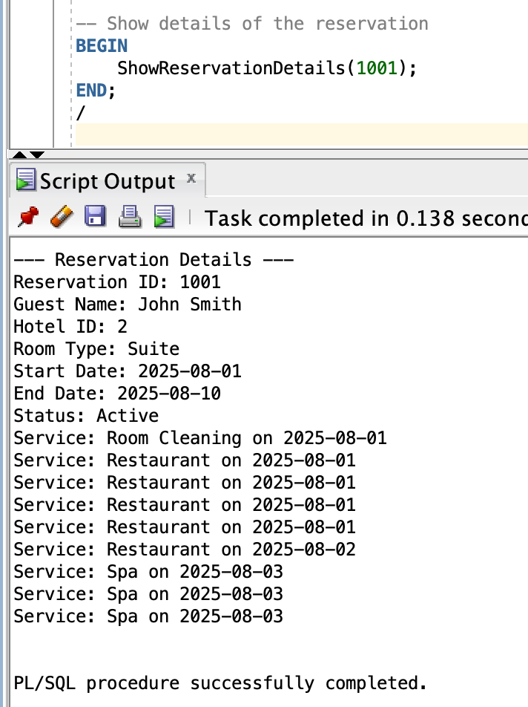

8. Cancel a reservation: Input the reservationID and mark the reservation as cancelled (do NOT delete it)

ALTER TABLE reservation ADD status VARCHAR2(20);

CREATE OR REPLACE PROCEDURE CancelReservation (

p_res_id IN NUMBER

) AS

BEGIN

UPDATE reservation

SET status = 'CANCELLED'

WHERE resid = p_res_id;

COMMIT;

DBMS_OUTPUT.PUT_LINE('Reservation cancelled: ID ' || p_res_id);

END;

/

-- Test Case

BEGIN

CancelReservation(1);

END;

-- Confirm cancellation

SELECT * FROM reservation WHERE resid = 1;

**Output:**

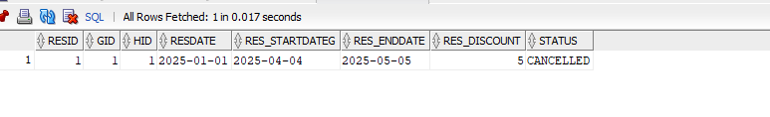

9. Change a reservationDate: Input the reservation ID and change reservation start and end date, if there is availability in the same room type for the new date interval SQL Code

CREATE OR REPLACE PROCEDURE ChangeReservationDates (

p_res_id IN NUMBER,

p_new_start IN VARCHAR2,

p_new_end IN VARCHAR2

) AS

v_hid NUMBER;

v_rtype VARCHAR2(50);

v_conflicts NUMBER;

BEGIN

SELECT r.hid, ro.rtype

INTO v_hid, v_rtype

FROM reservation r

JOIN reservation_room rr ON r.resid = rr.resid

JOIN room ro ON rr.rid = ro.rid

WHERE r.resid = p_res_id

AND (r.status IS NULL OR r.status != 'CANCELLED');

SELECT COUNT(*) INTO v_conflicts

FROM reservation r2

JOIN reservation_room rr2 ON r2.resid = rr2.resid

JOIN room ro2 ON rr2.rid = ro2.rid

WHERE r2.hid = v_hid

AND ro2.rtype = v_rtype

AND (r2.status IS NULL OR r2.status != 'CANCELLED')

AND r2.resid <> p_res_id

AND (

(p_new_start BETWEEN r2.res_startDateg AND r2.res_endDate) OR

(p_new_end BETWEEN r2.res_startDateg AND r2.res_endDate) OR

(r2.res_startDateg BETWEEN p_new_start AND p_new_end) OR

(r2.res_endDate BETWEEN p_new_start AND p_new_end)

);

IF v_conflicts > 0 THEN

DBMS_OUTPUT.PUT_LINE('Cannot change dates. Conflict found for room type ' || v_rtype);

ELSE

UPDATE reservation

SET res_startDateg = p_new_start, res_endDate = p_new_end

WHERE resid = p_res_id;

COMMIT;

DBMS_OUTPUT.PUT_LINE('Reservation dates updated for ID: ' || p_res_id);

END IF;

EXCEPTION

WHEN NO_DATA_FOUND THEN

DBMS_OUTPUT.PUT_LINE('Reservation ID not found or cancelled: ' || p_res_id);

END;

/

**Test Data:**

BEGIN

ChangeReservationDates(2, '2025-04-10', '2025-05-10');

END;

/

SELECT * FROM reservation WHERE resid = 2;

**Output:**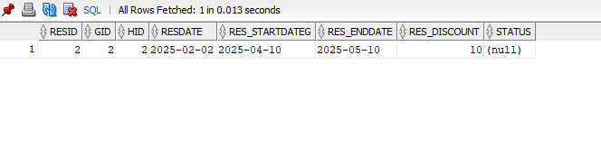

10. Change a reservationRoomType: Input the reservation ID and change reservation room type if there is availability for that room type during the reservation’s date interval

-- Change the reservation type

CREATE OR REPLACE PROCEDURE change_reservation_room_type(

p_resid NUMBER,

p_new_room_type VARCHAR2

) AS

v_hid NUMBER;

v_start DATE;

v_end DATE;

v_avail NUMBER;

BEGIN

SELECT hid, start_date, end_date INTO v_hid, v_start, v_end

FROM reservation

WHERE resid = p_resid;

v_avail := available_rooms_during(v_hid, p_new_room_type, v_start, v_end);

IF v_avail > 0 THEN

UPDATE reservation

SET room_type = p_new_room_type

WHERE resid = p_resid;

DBMS_OUTPUT.PUT_LINE('Room type updated.');

ELSE

DBMS_OUTPUT.PUT_LINE('No available rooms of that type in the date range.');

END IF;

EXCEPTION

WHEN OTHERS THEN

DBMS_OUTPUT.PUT_LINE('Error changing room type.');

END;

/

**Output:**

11. Available rooms at hotel: Input a specific hotel ID, a room type, and a date internal. Return the number of available rooms of that type during the interval

-- FUNCTION TO CHECK AVAILABLE ROOMS

CREATE OR REPLACE FUNCTION available_rooms_during(

p_hid NUMBER,

p_room_type VARCHAR2,

p_start_date DATE,

p_end_date DATE

) RETURN NUMBER AS

total NUMBER;

reserved NUMBER;

BEGIN

SELECT total_rooms INTO total

FROM room

WHERE hid = p_hid AND room_type = p_room_type;

SELECT COUNT(*) INTO reserved

FROM reservation

WHERE hid = p_hid AND room_type = p_room_type

AND (start_date <= p_end_date AND end_date >= p_start_date);

RETURN total - reserved;

EXCEPTION

WHEN OTHERS THEN

DBMS_OUTPUT.PUT_LINE('Error checking availability.');

RETURN -1;

END;

/

**Output:**

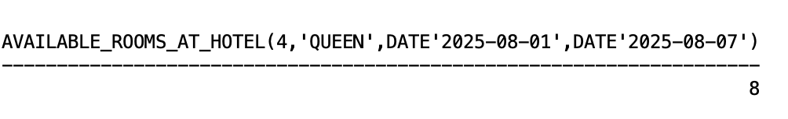

12. AvailabilityOfRoomHotelPerInterval: Input a room type, hotel ID, date interval and return the number of available rooms during that time interval

-- To find hotel availability

CREATE OR REPLACE FUNCTION available_rooms_at_hotel(

p_hid NUMBER,

p_room_type VARCHAR2,

p_start_date DATE,

p_end_date DATE

) RETURN NUMBER AS

BEGIN

RETURN available_rooms_during(p_hid, p_room_type, p_start_date, p_end_date);

END;

/

**Output:**

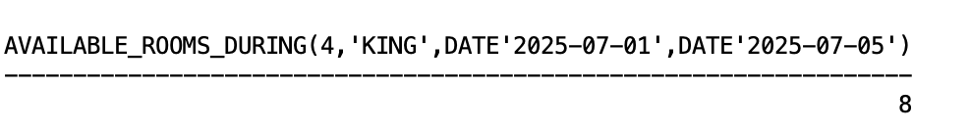

13. RoomCheckoutReceipt: Input: ReservationID Output: a. Guest name b. Room number, rate per day and possibly multiple rooms (if someone reserved several rooms) c. Services rendered per date, type, and amount d. Discounts applied (if any) e. Total amount to be paid

SELECT

r.resid AS reservation_id,

g.gname AS guest_name,

ro.rnumber AS room_number,

ro.r_ratePerNight AS rate_per_day,

TO_DATE(r.res_endDate, 'YYYY-MM-DD') - TO_DATE(r.res_startDateg, 'YYYY-MM-DD') AS num_days,

(ro.r_ratePerNight * (TO_DATE(r.res_endDate, 'YYYY-MM-DD') - TO_DATE(r.res_startDateg, 'YYYY-MM-DD'))) AS room_total,

s.sdate AS service_date,

s.stype AS service_type,

s.sprice AS service_amount,

r.res_discount AS discount_percent,

ROUND(

(

(ro.r_ratePerNight * (TO_DATE(r.res_endDate, 'YYYY-MM-DD') - TO_DATE(r.res_startDateg, 'YYYY-MM-DD')))

+ NVL(s.sprice, 0)

) * (1 - NVL(r.res_discount, 0) / 100),

2

) AS total_amount_due

FROM reservation r

JOIN guest g ON r.gid = g.gid

JOIN reservation_room rr ON r.resid = rr.resid

JOIN room ro ON rr.rid = ro.rid

LEFT JOIN service s ON r.resid = s.resid

WHERE r.resid = 1

**Output:**



Explanation - In the example above I used a reservation id for “Barack Obama” which compiled the information for his reservation to give this result.

14. SoldHotels: Print all sold hotel information. Show ID, location, etc.

set serveroutput on

-- this was in my D2 but including it just incase alter table hotel add (is_sold number default 0); -- set all hotels to unsold just in case

update hotel set is_sold = 0;

commit;

-- set 2 hotels to sold. i modified the original SQL procedure a bit after this but it should be fine

exec sell_hotel(2);

exec sell_hotel(4);

-- commit to be sure

commit;

-- starts the procedure

create or replace procedure print_sold_hotels as

begin

-- loops & prints relevant data where is_sold=1

for r in (

-- fields to print, any order is fine apparently

select hid, hcity, hname, hphone, hstate, haddress from hotel

where is_sold = 1

) loop

dbms_output.put_line('Sold Hotel:');

dbms_output.put_line('---');

dbms_output.put_line('ID: ' || r.hid);

dbms_output.put_line('Name: ' || r.hname); dbms_output.put_line('Address: ' || r.haddress); dbms_output.put_line('City: ' || r.hcity); dbms_output.put_line('State: ' || r.hstate); dbms_output.put_line('Phone: ' || r.hphone); dbms_output.put_line('---');

end loop;

end;

/

**Screenshot**

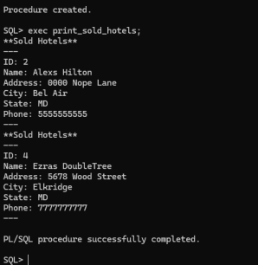

**Testing**

-- run command

exec print_sold_hotels;\

15. ShowCancelations: Print all canceled reservations in the hotel management system.Show reservation ID, hotel name, location, guest name, room type, dates

ALTER TABLE reservation ADD res_status VARCHAR2(20);

UPDATE reservation SET res_status = 'CANCELED' WHERE resid = 2;

UPDATE reservation SET res_status = 'ACTIVE' WHERE resid IN (1, 3);

BEGIN

DBMS_OUTPUT.PUT_LINE('Canceled Reservations');

DBMS_OUTPUT.PUT_LINE('---------------------------------------------------------------');

FOR rec IN (

SELECT r.resid,

h.hname AS hotel_name,

h.hcity || ', ' || h.hstate AS location,

g.gname AS guest_name,

ro.rtype AS room_type,

r.res_startDateg AS start_date,

r.res_endDate AS end_date

FROM reservation r

JOIN hotel h ON r.hid = h.hid

JOIN guest g ON r.gid = g.gid

JOIN reservation_room rr ON r.resid = rr.resid

JOIN room ro ON rr.rid = ro.rid

WHERE r.res_status = 'CANCELED'

) LOOP

DBMS_OUTPUT.PUT_LINE(

'Reservation ID: ' || rec.resid || ' | ' ||

'Hotel: ' || rec.hotel_name || ' | ' ||

'Location: ' || rec.location || ' | ' ||

'Guest: ' || rec.guest_name || ' | ' ||

'Room Type: ' || rec.room_type || ' | ' ||

'Dates: ' || rec.start_date || ' to ' || rec.end_date

);

END LOOP;

END;

/

SET SERVEROUTPUT ON;

**Output:**



16. SpecificHotelReport: Input: hotelID, start-date, end-date. Print (for the given time interval): a. Income by room type b. Income of services, by service type c. Total income from all sources.

VARIABLE hotel_id NUMBER;

VARIABLE start_date VARCHAR2(20);

VARIABLE end_date VARCHAR2(20);

EXEC :hotel_id := 1;

EXEC :start_date := '2024-01-01';

EXEC :end_date := '2024-12-31';

SELECT

ct.ctname AS room_type,

SUM(t.fare) AS income

FROM trip t

JOIN car c ON t.cid = c.cid

JOIN car_type ct ON c.ctid = ct.ctid

WHERE ct.ctid = :hotel_id

AND t.start_time BETWEEN TO_DATE(:start_date, 'YYYY-MM-DD') AND TO_DATE(:end_date, 'YYYY-MM-DD') GROUP BY ct.ctname;

SELECT

'Trip Fare' AS service_type,

SUM(t.fare) AS income

FROM trip t

JOIN car c ON t.cid = c.cid

WHERE c.ctid = :hotel_id

AND t.start_time BETWEEN TO_DATE(:start_date, 'YYYY-MM-DD') AND TO_DATE(:end_date, 'YYYY-MM-DD');

SELECT

SUM(t.fare) AS total_income

FROM trip t

JOIN car c ON t.cid = c.cid

WHERE c.ctid = :hotel_id

AND t.start_time BETWEEN TO_DATE(:start_date, 'YYYY-MM-DD') AND TO_DATE(:end_date, 'YYYY-MM-DD');

**Output:**

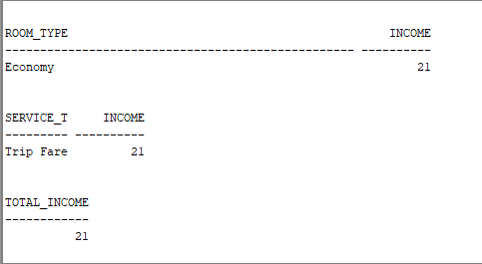

17. TotalHiltontMontlyReport: Total income from all sources of all hotels. Totals must be printed by month, and for each month by room type, service type. Include discounts.

-- Monthly Report

CREATE OR REPLACE PROCEDURE total_hilton_monthly_report AS

BEGIN

DBMS_OUTPUT.PUT_LINE('Hilton Monthly Income Report (Room + Services)');

DBMS_OUTPUT.PUT_LINE('------------------------------------------------');

FOR rec IN (

SELECT

TO_CHAR(r.start_date, 'YYYY-MM') AS month,

r.room_type,

NULL AS service_type,

COUNT(*) AS num_res,

SUM(

(rr.price_per_night * (r.end_date - r.start_date + 1)) *

(1 - NVL(r.discount_percent, 0) / 100)

) AS room_income,

0 AS service_income

FROM reservation r

JOIN room rr ON r.hid = rr.hid AND r.room_type = rr.room_type

WHERE r.hid = 4 -- Hilton

GROUP BY TO_CHAR(r.start_date, 'YYYY-MM'), r.room_type

UNION ALL

SELECT

TO_CHAR(r.start_date, 'YYYY-MM') AS month,

r.room_type,

s.service_type,

COUNT(*) AS num_res,

0 AS room_income,

SUM(s.base_price * rs.quantity) AS service_income

FROM reservation r

JOIN reservation_service rs ON r.resid = rs.resid

JOIN service s ON rs.service_type = s.service_type

WHERE r.hid = 4 -- Hilton

GROUP BY TO_CHAR(r.start_date, 'YYYY-MM'), r.room_type, s.service_type

)

LOOP

DBMS_OUTPUT.PUT_LINE('Month: ' || rec.month || ' | Room Type: ' || rec.room_type ||

' | Service: ' || NVL(rec.service_type, 'Room Charge') ||

' | Room Income: $' || rec.room_income ||

' | Service Income: $' || rec.service_income);

END LOOP;

EXCEPTION

WHEN OTHERS THEN

DBMS_OUTPUT.PUT_LINE('Error generating monthly report.');

END;

/

-- Runs Report

BEGIN

total_hilton_monthly_report;

END;

/

**Output:**

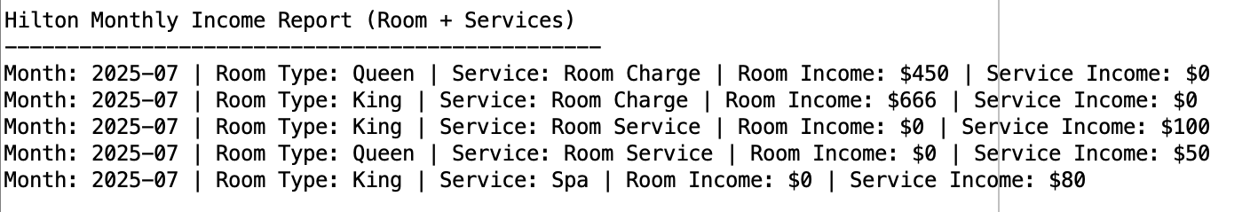

18. TotalHiltontStateReport: Input is state. Print total income from all sources of all hotels by room type and service type in the given state. Include discounts

-- this procedure prints the total income from all sources of all hotels

create or replace procedure totalhiltonstatereport(p_state in varchar2) as

-- grabs hotel + room + reservation + service data for a specific state

cursor state_data is

select h.hname,

rm.rtype,

rm.r_ratepernight,

s.stype,

s.sprice,

res.res_discount

from hotel h

join room rm on h.hid = rm.hid

left join reservation_room rr on rm.rid = rr.rid

left join reservation res on rr.resid = res.resid

left join service s on res.resid = s.resid

where h.hstate = p_state;

v_totalroomincome number := 0;

v_totalserviceincome number := 0;

v_nettotal number := 0;

v_avg_discount number := 0;

begin

dbms_output.put_line('--- total hilton state report for ' || p_state || ' ---');

-- loop through each row

for rec in state_data loop

if rec.r_ratepernight is not null then

v_totalroomincome := v_totalroomincome + rec.r_ratepernight;

end if;

if rec.sprice is not null then

v_totalserviceincome := v_totalserviceincome + rec.sprice;

end if;

end loop;

-- calculate average discount

select nvl(avg(res.res_discount), 0)

into v_avg_discount

from reservation res

join hotel h on res.hid = h.hid

where h.hstate = p_state;

-- apply the discount

v_nettotal := (v_totalroomincome + v_totalserviceincome) * (1 - v_avg_discount / 100);

-- output sum

dbms_output.put_line('total room income: $' || v_totalroomincome);

dbms_output.put_line('total service income: $' || v_totalserviceincome);

dbms_output.put_line('average discount applied: ' || to_char(v_avg_discount, '999.99') || '%');

dbms_output.put_line('net total income: $' || to_char(v_nettotal, '9999.99'));

end;

/

-- test:

exec totalhiltonstatereport('MD');

**Output:**

